JAL REKHA PROJECT
CHANGE REQUEST DOCUMENT
June – July 2026
O&M Billing · Sahbhagita · Cube Testing · Dhara · Master Module
Project | Jal Rekha – O&M Billing, Sahbhagita, Cube Testing, Dhara & Master Modules
Client / Department | Jal Nigam, Government of Madhya Pradesh
Contract Reference | MPSEDC/MPSSDI(GIS)/2025/00423
Document Title | Change Request Document – June–July 2026
Cycle / Sprint | Cycle 4 – Jal Rekha/17 (01 Jun 2026 – 31 Jul 2026)
Prepared By | Dheeraj Motiyani, Senior Business Analyst, MPSeDC
Reviewed By | Tapan Khandelwal, Senior Project Manager
Source References | MD Sir MoM – 9-Jun-2026 & 16-Jun-2026; June Month Change-Request Notes; O&M Billing Workflow Process-Flow diagrams; Document-Upload wireframes; CR Register May–Jun 2026
Document Date | 10-Jul-2026
Version | 1.0

1. Purpose & Scope
This document consolidates all Change Requests (CRs), design changes and enhancements raised for the Jal Rekha platform during the June–July 2026 window (Cycle 4, Sprint Jal Rekha/17), covering the O&M Billing, Sahbhagita, Cube Testing, Dhara and Master modules. It is intended to serve as the single reference for development, QA and stakeholder sign-off for this period.
The document is organised as follows:
- Section 2 – Executive summary of CR counts by module and status.
- Section 3 – Consolidated Change Request log (all CRs raised/carried forward for June–July).
- Section 4 – Detailed write-up for each requested change area (Save-as-Draft/mandatory uploads, Residual Pressure, Complaint Redressal, O&M Billing workflow, Sahbhagita, Cube Testing, Master-module locking, O&M design changes, O&M Abstract Bill).
- Section 5 – O&M Billing workflow – process-flow reference and document-upload matrix.
- Section 6 – Enhancements already completed (May–June 2026) as background/context.
- Section 7 – Approval and sign-off.

2. Executive Summary
21 Change Requests are tracked for the June–July window across five modules. 3 are completed, 7 are in progress and 11 remain open pending development/UAT.
Module | Total CRs | Completed | In Progress | Open | Priority Focus
O&M Billing | 13 | 0 | 5 | 8 | High
Sahbhagita | 4 | 1 | 1 | 2 | Medium–High
Cube Testing | 1 | 1 | 0 | 0 | Medium
Master | 1 | 0 | 0 | 1 | High
Dhara | 2 | 1 | 1 | 0 | High
TOTAL | 21 | 3 | 7 | 11 | —

3. Consolidated Change Request Log
The table below lists every CR in scope for June–July 2026. New items raised this cycle use the CR-JR-JUN-xxx code; items carried forward from the May–June register retain their original CR-JR-MAY-xxx code.
CR No. | Module | Description | Priority | Status | Sprint
CR-JR-JUN-001 | O&M Billing | Contractor/Firm login – make key document uploads (Submission Letter, Tax Invoice) mandatory before a bill can move out of “Save as Draft” state; draft can be saved with partial data but cannot be forwarded to GM (PIU) until mandatory documents are attached. | High | Open | Jal Rekha/17
CR-JR-MAY-020 | O&M Billing | Residual Pressure screen/report changes – District, Block, GP, Village, Consumer, Mobile, Measured Pressure, Remark, Affected HSCs × Days columns; penalty calculation logic as per Pressure Threshold Report format. | Medium | Open | Jal Rekha/17
CR-JR-JUN-002 | O&M Billing | Complaint Redressal Sheet – add Complaint Received Date to Contractor, Event-above-48-hours flag and Penalty Relaxation (Yes/No) fields; document upload as per submeter reading. | Medium | Open | Jal Rekha/17
CR-JR-MAY-006 | O&M Billing | Workflow redesign: Firm → GM (PIU) → [GM (O&M) direct] and Firm → GM (PIU) → TL (SQC) → GM (PIU) → GM (O&M) → DGM → TL (PMC) → GM (O&M) → CGM → CA → CFO → P.D. → MD. | High | In Progress | Jal Rekha/17
CR-JR-MAY-002 | O&M Billing | Contractor RA Bill Abstract – Select Bill → Generate Abstract → auto-tag all villages; abstract linked to selected bill only. | High | In Progress | Jal Rekha/16
CR-JR-JUN-003 | O&M Billing | O&M Abstract Bill – Village-wise and Combined Activity abstract report; Category filter (Village/Combined/All); quarterly RA Bill numbering (RA/1 – RA/12) reflected on abstract header. | High | Open | Jal Rekha/17
CR-JR-MAY-005 | O&M Billing | Bill PDF consolidation – merge ~19–20 supporting documents into one PDF; static documents (GM/SQC/Firm/Form27A/MB/Abstract) carried once per quarter, variable documents per month; landscape layout issue fixed. | High | In Progress | Jal Rekha/16
CR-JR-MAY-008 | O&M Billing | Contractor mistakes made visible to SQC/TL/GM across all logins; merged PDF of all O&M documents available on every ID. | Medium | Open | Jal Rekha/17
CR-JR-MAY-015 | O&M Billing | Document Upload screen redesign – separate Firm, TL/SQC and GM (PIU) sections; Upload / Download / View PDF actions; multiple-file support and Remark field for select document types. | High | In Progress | Jal Rekha/17
CR-JR-MAY-003 | O&M Billing | GST No. integration with O&M Billing – captured at contractor/firm master level and reflected on bill and abstract. | Medium | Open | Jal Rekha/17
CR-JR-MAY-001 | O&M Billing | E-Sign integration (CDAC, Aadhaar-based) across Firm, FE, Contractor and GM (PIU) logins for Bill, Submission Letter and Abstract; Web + Mobile flow; system-generated bill does not require physical signature. | High | Open | Jal Rekha/17
CR-JR-MAY-004 | O&M Billing | TL Recommendation Letter to be E-Office generated and routed to Account Office (Jal Rekha) instead of manual upload. | High | Open | Jal Rekha/17
CR-JR-MAY-014 | O&M Billing (Aaklan) | GM (PIU) and GM (O&M)/Deputy (O&M) – View Pending Bills and Manage Bill screens; already-generated bills shown in table before onward routing. | High | In Progress | Jal Rekha/17
CR-JR-JUN-004 | Sahbhagita | Report restructuring – Category (Village-wise / Combined) × Activity matrix; Village-wise 32 listed (27 unique) activities, Combined 22 activities; V/C/A cross-filter on report screen. | High | In Progress | Jal Rekha/17
CR-JR-MAY-007 | Sahbhagita | Multi-select dropdown for RA Bill selection, RA(1) through RA(12), with a Withhold Bills option. | Medium | Open | Jal Rekha/17
CR-JR-MAY-013 | Sahbhagita | Hyperlink Village Name and Village Activity Document to open a preview popup of the uploaded activity document. | Medium | In Progress | Jal Rekha/17
CR-JR-MAY-012 | Sahbhagita | Future scope – Photo/Video capture at CP Manager stage with AI face + background model; duplicate/repeated photo detected and flagged “Already Used Before”. | Low | Open | Future Sprint
CR-JR-JUN-005 | Cube Testing | Cube ID generated before image upload (removes dependency on image for ID creation); rejected inspection data made visible back to Contractor login for correction and resubmission. | Medium | Completed | Jal Rekha/17
CR-JR-JUN-006 | Master | Lock master-data entries once linked to live transactions – Scheme Master, Village Master and OHT Master fields become non-editable after being tagged/used in Dhara, O&M Billing or Asset Mapping records; edits require a controlled change flow. | High | Open | Jal Rekha/17
CR-JR-MAY-009 | Dhara | Approved report data locked from further edit; GM (PIU)/TL may add (not edit) records on a contractor-generated bill; GM may add a new penalty point. | High | In Progress | Jal Rekha/16
CR-JR-MAY-021 | Dhara | Non-mandatory options (Remark, Photo Upload, Forward, Backward) enabled across all logins. | High | Completed | Jal Rekha/17

4. Detailed Change Requests

4.1 Mandatory Document Upload on “Save as Draft” – Contractor / Firm (O&M Billing)
CR No.: CR-JR-JUN-001 | Priority: High | Status: Open
Requirement: When the Contractor/Firm saves an O&M bill as Draft, the system currently allows the bill to be saved with any combination of documents attached. This CR introduces a mandatory-document check that is enforced before the draft can be forwarded (submitted) to GM (PIU) – not at the point of saving the draft itself.
- A bill can be saved as Draft at any point, with partial data and without any document uploaded (no change to this behaviour).
- Before the “Forward to GM (PIU)” action is enabled, the Firm Submission Letter and Tax Invoice must be uploaded; the bill remains locked in Draft state otherwise.
- The Draft list clearly flags which mandatory documents are still missing, so the Contractor knows what is pending before final submission.
- This mirrors the pattern already delivered for Cube Testing (mandatory multi-image upload + Save as Draft) and Sahbhagita Mobile (Save as Draft for video/image/documents).

4.2 Residual Pressure – Report & Screen Changes
CR No.: CR-JR-MAY-020 | Priority: Medium | Status: Open
The Residual Pressure screen and report are being aligned to the Pressure Threshold Report format:
- Columns: District, Block, Gram Panchayat, Village, Consumer Name, Mobile Number, Measured Pressure (in metres), Remark, No. of additional affected HSCs (where measured pressure is below agreement norms), No. of days the pressure problem persisted, and the derived value – No. of affected HSCs × No. of days.
- The derived penalty-input value auto-calculates as HSCs × Days for use in the O&M Billing penalty computation.
- RA Bill Duration, Financial Year and Month selectors on the O&M Billing screen filter the Residual Pressure entries shown for that billing cycle.
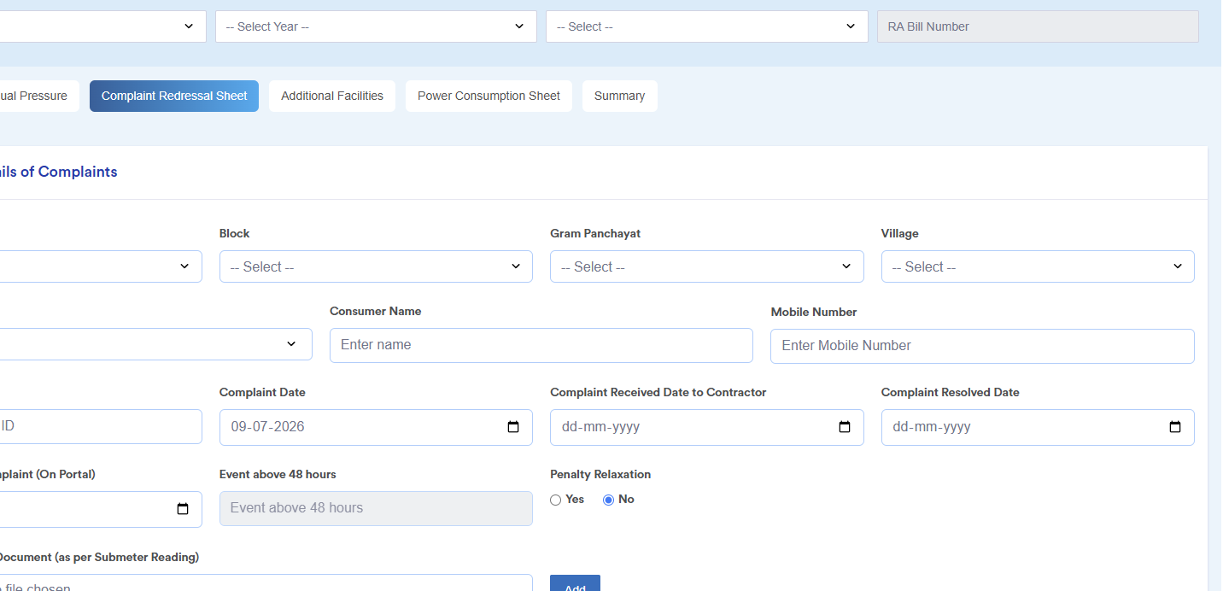
Fig. 1 – Complaint Redressal Sheet screen (reference wireframe) showing the fields shared with the Residual Pressure module.

4.3 Complaint Redressal Sheet – Changes
CR No.: CR-JR-JUN-002 | Priority: Medium | Status: Open
Complaint Redressal Sheet (tab alongside O&M Bill, Residual Pressure, Additional Facilities, Power Consumption Sheet and Summary) is being extended with:
- Block / Gram Panchayat / Village cascading filters and Consumer Name, Mobile Number capture on each complaint entry.
- Complaint Date, Complaint Received Date to Contractor, and Complaint Resolved Date fields.
- An “Event above 48 hours” flag that is auto-derived from the received/resolved dates.
- A Penalty Relaxation (Yes/No) radio option, with the associated relaxation letter uploaded under the GM (PIU) document set when “Yes” is selected.
- Supporting-document upload “as per Submeter Reading” against each complaint row.

4.4 O&M Billing – Workflow / Process-Flow Redesign
CR No.: CR-JR-MAY-006 | Priority: High | Status: In Progress
The O&M Billing approval chain has been redesigned into a single 13-stage process flow (see Section 5.1 for the full step-by-step reference and diagram), with two access paths from GM (PIU):
- Path A – Firm → GM (PIU) → GM (O&M) directly, for cases that do not require TL (SQC) review.
- Path B – Firm → GM (PIU) → TL (SQC) → GM (PIU) → GM (O&M) → DGM (O&M) → TL (PMC) → GM (O&M) → CGM → CA → CFO → P.D. → MD, for the full review-and-approval chain.
- A “Manage Bill” page (as opposed to the earlier flow) is used at every stage for Edit/Add and Forward/Recommend actions, with “View Pending Bills” available before a bill reaches the Pending queue of the next role.

4.5 Sahbhagita – Module Changes
Four items are in scope for Sahbhagita this cycle:
- CR-JR-JUN-004 (High, In Progress) – Report restructuring into a Category × Activity matrix: Village-wise view (32 activities listed, 27 unique) and Combined view (22 activities), with a Village/Combined/All (V/C/A) cross-filter on the Abstract of RA Bill report.
- CR-JR-MAY-007 (Medium, Open) – Multi-select bill dropdown, RA(1) through RA(12), plus a Withhold Bills toggle.
- CR-JR-MAY-013 (Medium, In Progress) – Village Name and Village Activity Document hyperlinks that open a document-preview popup.
- CR-JR-MAY-012 (Low, Open, future scope) – AI-assisted photo/video verification at CP Manager stage with duplicate-photo detection and an “Already Used Before” flag.
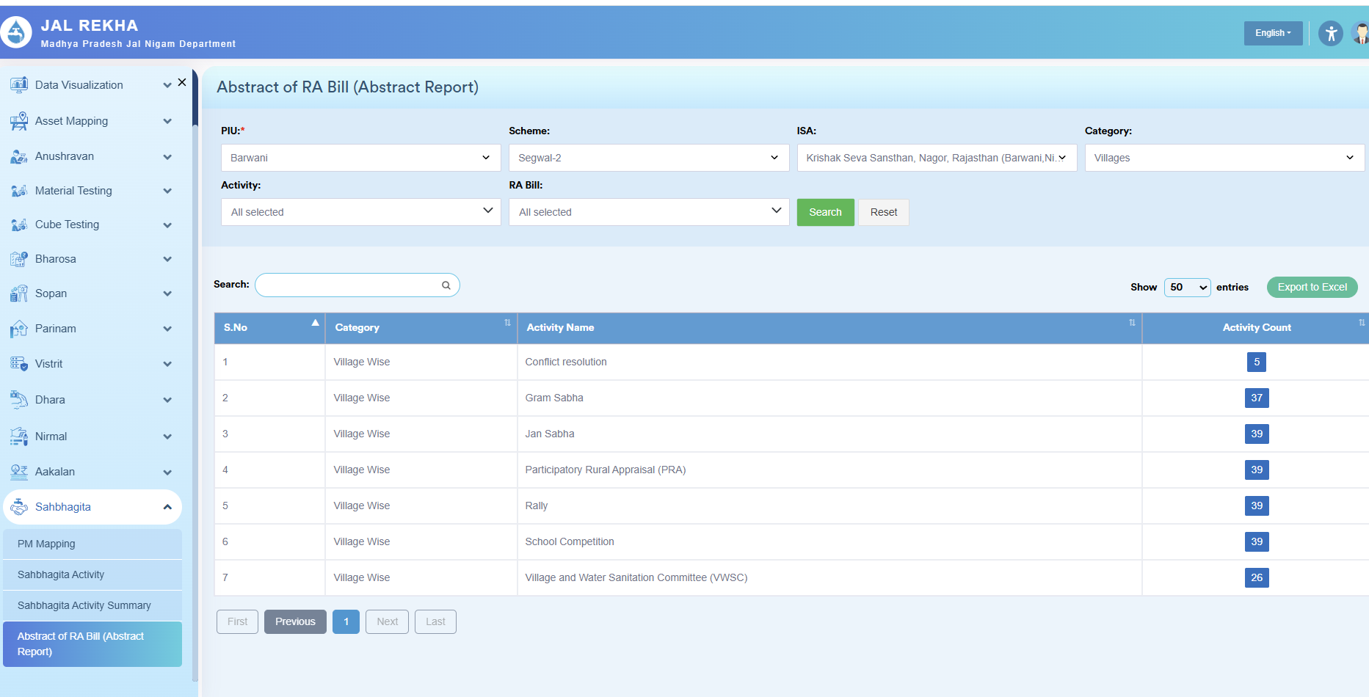
Fig. 2 – Abstract of RA Bill (Abstract Report) screen – PIU / Scheme / ISA / Category / Activity / RA Bill filters feeding the Village-wise and Combined activity counts.

4.6 Cube Testing – Module Changes
CR No.: CR-JR-JUN-005 | Priority: Medium | Status: Completed
- Cube ID is now generated before the inspection image is uploaded, removing the earlier dependency of ID creation on a successful image upload.
- Rejected cube-inspection records are now shown back to the Contractor login so corrections can be made and the record resubmitted.
Background (already delivered, Jan–May 2026): FE 7th/28th-day sync and validation, GM summary/action reports, SQC/TPIA approval workflow, and mandatory multi-image upload with manual-entry fallback – 5 CRs, all completed (see Section 6).

4.7 Master Module – Lock Scheme, Village and OHT Entries
CR No.: CR-JR-JUN-006 | Priority: High | Status: Open
Scheme Master, Village Master and OHT Master records currently remain editable indefinitely. This CR introduces a lock once a record is referenced by a live transaction:
- A Scheme, Village or OHT record becomes read-only once it has been tagged/used in a Dhara report, O&M Billing entry or Asset Mapping (BISAC) record.
- GM (PIU) side, all locked master details are view-only; any further correction must go through a controlled change/relaxation flow rather than a direct edit.
- This is consistent with the Dhara “approved-report lock” principle already agreed (CR-JR-MAY-009) and extends the same discipline to the Master data layer that feeds Vistrit, Dhara and O&M Billing.

4.8 O&M Module – Design / UI Changes
Several UI/UX and document-handling fixes are grouped under the O&M module design changes:
- CR-JR-MAY-005 (High, In Progress) – Landscape print/layout issue on the O&M Bill PDF fixed; all bill documents merged into a single ~19–20-page PDF, with static documents (GM/SQC/Firm/Form 27A/MB/Abstract) carried once per quarter and variable documents refreshed every month.
- CR-JR-MAY-008 (Medium, Open) – Contractor-entered mistakes surfaced to SQC/TL and GM logins; all records visible on all relevant IDs.
- CR-JR-MAY-015 (High, In Progress) – Document Upload screen redesigned into three clearly separated blocks (Firm, TL/SQC, GM (PIU)), each with Upload / Download / View PDF actions; see the matrix in Section 5.2.
- Menu/navigation: O&M Billing sits under the Aakalan menu with Contract Details and Generate Bill sub-items; RA Bill Duration, Financial Year and Month selectors are pinned to the top of the O&M Billing, Residual Pressure, Complaint Redressal, Additional Facilities and Power Consumption Sheet tabs.
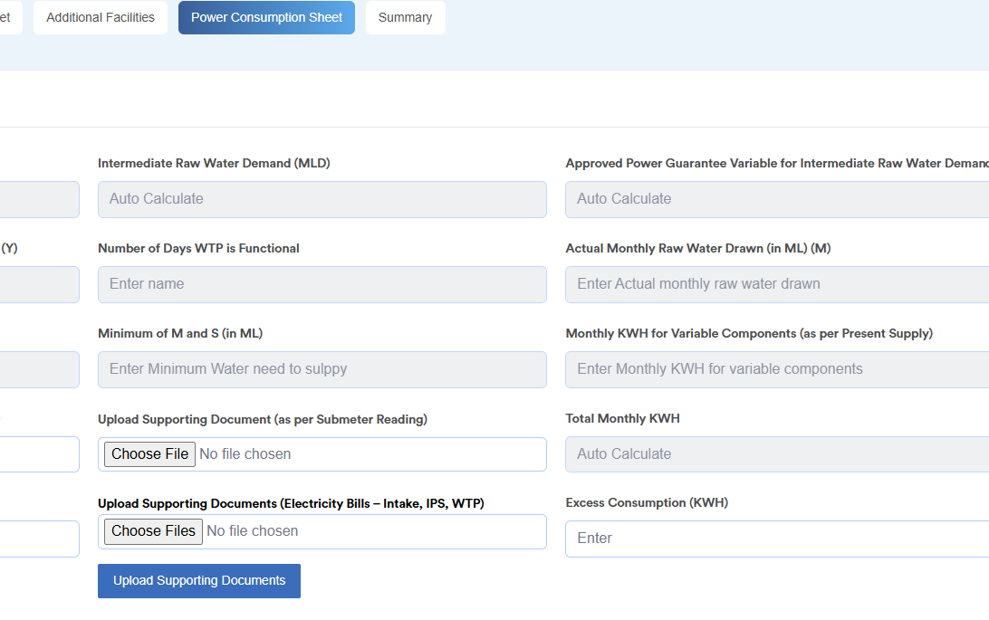
Fig. 3 – Power Consumption Sheet tab – auto-calculated fields and multi-file supporting-document upload, part of the O&M module design refresh.

4.9 O&M Abstract Bill – Changes
CR No.: CR-JR-MAY-002 / CR-JR-JUN-003 | Priority: High | Status: In Progress / Open
- Contractor login: Select Bill → Generate Abstract auto-tags all villages under the selected RA Bill (no manual village selection required).
- Abstract report is split by Category – Village-wise and Combined – mirroring the Sahbhagita activity-report structure, so the same abstract logic can be reused across modules.
- RA Bill numbering on the abstract follows the RA/1–RA/12 quarterly cycle, matching the Sahbhagita multi-select dropdown range.
- Abstract export (Export to Excel) and search/pagination retained as-is; only the underlying tagging and category logic changes.

5. O&M Billing – Process-Flow & Document Reference

5.1 13-Stage Approval Workflow
This is the end-to-end approval chain referenced by CR-JR-MAY-006 (Section 4.4). “Manage Bill” / “View Pending Bills” is available in parallel at every GM/TL/DGM stage.
Step | Actor / Role | Action
1 | Firm (Contractor) | Generates the O&M bill; uploads Submission Letter, electricity bills, PHE test reports and Tax Invoice. Bill is system-generated – physical signature is not required.
2 | GM (PIU) | Reviews the bill and forwards it to TL (SQC/CSC).
3 | TL (SQC/CSC) | Adds/edits bill data field-by-field and uploads a Recommendation Letter.
4 | GM (PIU) – 2nd stage | Adds/edits data; uploads Signed MB, Signed Abstract, Signed Monthly Bill Sheet and Signed Form 27A (plus relaxation letter, if applicable).
5 | GM (O&M) | Reviews and forwards the bill to DGM (O&M).
6 | DGM (O&M) | Departmental review; approves or holds with remarks.
7 | TL (PMC) | Issues Recommendation Letter with supporting documents.
8 | GM (O&M) – final | Uploads Pass Order copy (signed by DGM O&M) and the signed letter from Head Office.
9 | CGM | Regional-office review – Bhopal, Gwalior, Jabalpur, Rewa, Sagar, Indore or Ujjain.
10 | CA | Financial/accounts verification.
11 | CFO | Financial approval review.
12 | P.D. | Project Director endorsement.
13 | MD | Final approval and sanction.
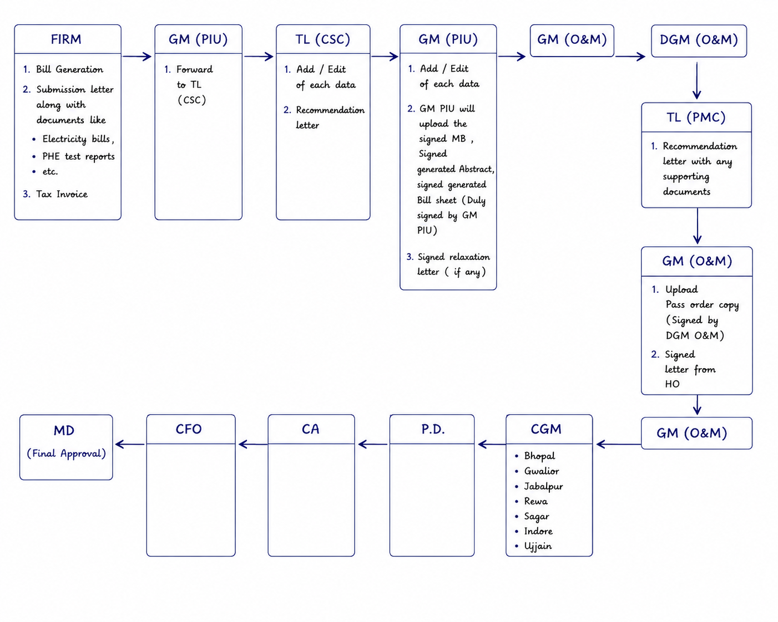
Fig. 4 – O&M Billing multi-level approval workflow: Firm → GM (PIU) → TL (CSC) → GM (PIU) → GM (O&M) → DGM (O&M) → TL (PMC) → GM (O&M) → CGM → CA → CFO → P.D. → MD.

5.2 Document Upload Matrix (per bill)
Reference matrix for the Document Upload screen redesign (CR-JR-MAY-015, Section 4.8). Every document row supports Upload, Download and View PDF actions.
Stage | Document | Multiple? | Remark Field?
Firm / Contractor | Firm Submission Letter | No | No
Firm / Contractor | Tax Invoice | No | No
Firm / Contractor | Any Other Documents (named) | Yes | Yes
TL / SQC | SQC Recommendation Letter | No | No
TL / SQC | Third Party Water Quality Test Report | Yes | Yes
TL / SQC | Any Other Documents (named) | Yes | Yes
GM (PIU) | PIU Recommendation Letter | No | No
GM (PIU) | Signed Form 27A | No | No
GM (PIU) | Signed Scanned MB | No | No
GM (PIU) | Signed Abstract | No | No
GM (PIU) | Signed Monthly Bill Sheet | Yes | No
GM (PIU) | Any Other Documents (named) | Yes | Yes

6. Enhancements Completed – May–June 2026 (Background)
For context, the following enhancements were completed in the immediately preceding period (per MD Sir’s review meetings dated 9-Jun-2026 and 16-Jun-2026) and form the baseline that the June–July CRs in Section 3 build upon.
Module | Enhancement | Status
Anushravan / Cube / Material | Removed mandatory Village/GP dropdown requirement on Intake, WTP, MBR, RWPM and CWPM forms. | Done
Anushravan / Cube / Material | Save-as-Draft functionality added; photo upload can be completed later. | Done
Anushravan / Cube / Material | OHT search option added during RFI. | Done
Anusharavan | FE RFI Submission date and Block name added to reports. | Done
Cube Testing | Structure components added under each Component; Filter Bed added as WTP sub-component; RFI-loop costing date (7th/28th day) added. | Done
Cube Testing (Mobile) | Mandatory multi-image upload on the FE inspection form; Save-as-Draft added. | Done
Cube Testing | Cube ID generated before image upload; rejected data shown to Contractor. | Done
Dhara | New Dhara report enabled on all Jal Rekha logins; GM-approved reports and contractor-dispute flow added. | Done
Dhara | Non-mandatory Remark / Photo Upload / Forward / Backward options live across all logins (19-Jun-2026). | Done
Sahbhagita | RA Bill functionality added on ISA Manager after activity approval, with Edit option. | Done
Sahbhagita | RA Bill routed to ISA (in place of CP Manager); pagination on approval pages; FE mapped and visible to specific ISA; ISA password-reset option added. | Done
Sahbhagita (Mobile) | Save-as-Draft added for video, image and document uploads. | Done
Vistrit | WTP/Intake meter mapping – Date, Scheme, PIU, meter name and connection-count columns added; naming convention standardised (e.g., Narela-WTP-01). | Done
Vistrit | Village-mapping validation applied to Testing/Permitted fields; Census Population left open at all levels; OHT visibility issue (deactivated entries) resolved. | Done
Vistrit & Dhara | All reports made visible on Contractor login (Vistrit data kept non-editable). | Done
O&M Billing | Dhara report integrated into O&M Billing; Census population added to Scheme Master; duplicate village-mapping validation added. | Done
O&M Billing | Master – Scheme/Village master and OHT/Village master completed; Bulk Consumer and Bulk Consumer–OHT/WTP mapping completed. | Done
O&M Billing | Power Consumption – Contractor/GM side changes (Contract Details, Intermediate Raw Water Demand); two additional columns added to Water-Supply-During-Construction bill. | Done
O&M Billing | GM approval simplified to single final approval (provisional approval removed); Concern Remark made mandatory. | Done
O&M Billing | 10% deduction rule applied automatically when GM marks Pump/Transformer = Yes on the consolidated bill. | Done
Open Platform / Public | DWSR opened to public; reports restricted to Dhara & DWSR only; DWSR column made a clickable hyperlink; redundant reports removed. | Done
SVS (Water Supply Monitoring) | JJM ID and Village-status fields removed; login-specific District/Block/GP filter added; bilingual (Hindi/English) conversion completed. | Done
Parinam | Contractor search option added; FE name shown in reports. | Done

7. Approval & Sign-off
This Change Request document is submitted for review and approval by the following stakeholders prior to development and UAT planning for Sprint Jal Rekha/17.
Role | Name | Signature | Date
Prepared By | Dheeraj Motiyani (Sr. BA)
Reviewed By | Tapan Khandelwal (SPM)
Approved By | MD Sir

Appendix – Source Documents
- Jal_rekha_Modules_Change_request_June_Month.pdf – handwritten daily meeting notes (29-May to 11-Jun 2026).
- MD_Sir_Jal_Rekha_MoM_Points_-_9-June-2026_V_1_1.xlsx and –_16-June-2026_V_1_2.xlsx.
- O_M_billing_workflow_ka_Processflow.pdf and Jal_Rekha_OM_Billing_Workflow.docx (digitised process-flow diagram).
- Jal_Rekha_OM_Billing_Workflow_User_Stories_May_to_june.xlsx.
- CR_Register_JalRekha_May_Jun_2026.xlsx and Jal_Rekha_CR_Log_Cycle4_Jan_May_2026_V1_5.xlsx.
- ResidualPressurePDF.pdf, Power_Consuption.xlsx, master_activity_updated_list.xlsx, document_list.jpeg, MockUp_-_OM_Billing_Workflow_Wireframe-ProcessFlow.html.

